- Over all, sounds good

- I should be good to do 20-25 hours per week to Hunger's development. That should be enough to get it setup for 100s of Users in the next month or so?

- I think I can move the AFit in the Apple and Google store back to "Close Testing".
- Hide the existing screens and add the 3 new ones from the Design Doc.

- I'll keep https://assistant-fitness.com and the Apps setup for just our Users (and a white list)... e.g.
- app-dev.assistant-fitness.com (for dev),
- app-test.assistant-fitness.com (for integration tests)
- app.assistant-fitness.com (for whitelisted external users)
E.g. like https://hunger-v3-349828425059.us-east1.run.app/

- Then, how is the User Flow outside of these 3 screens?

My Feelings/Key Takeaways

Legend:
- Black: Matt
- Red: Thad
- Blue: Direct quotes from Josh’s “Hunger.” docs

Would it work?
- E.g. What are the odds this plan would be break-env by year 1?
- Personally, I don’t know if there are enough people motivated by hatred for fitness App/SocialMedia lies to buy into this? Seems likely, but I’m not the ICP. I just don’t know…There are a vast amount of people (especially in Gen z who wish to go “against the grain”, do not want what everyone else has/uses and marketing to them is the entire eco-sphere of their existence. Hence why content creators on a variety of different platforms(Mr. Beast for example )have created a massive amount of wealth on simple entertainment. Hunger. Feeds into that narrative-speaks to them and if the tech is right provides significant value
- So, I showed the Design Doc to someone in the ICP… my 15yearold daughter. I would categorize her reaction as "resonated"... E.g.
  - Me: Take a look at this big ass document…
  - Her: "Hell yeah. This is cool... "
  - Me: “Is this real? Toxic social media, manipulative apps, etc... Are people really having real problems with it?“
  - Her: "Yes, like every day people struggle with this.. At school, my friends, pretty much everybody..."

- Re: “The 36-month vision of being the default. I genuinely think this is achievable with this brand position. I also think the same thing was said by 200 other consumer founders in 2026 and 190 of them won't get there. The position is right. The execution is the thing that determines which side of the 200 we're on.” – HUNGER. THE MARKETING PLAYBOOK I would push back with a question and say what would you have thought about Liquid Death or Dude Wipes in their conceptual early stages. Do not underestimate the value of creative marketing/brand awareness to a selective group along with how the marketing to them ensures adoption
  - 5% chance of success @ $100k/quarter. Yeah, that sounds reasonable…
  - Seems like a quality well thought out plan…
  - So, I’d even double the odds to 10% chance of success/break even by year1.

Would I do it?
- Be the CTO/CoFounder for this App for +1year
- Set it up for success. Make improvements. Strive for 9s. Fix it when it breaks. Get feedback. Make sure it’s helping the User.
- Sell the Vision. Explain the Tech.
- Hell yeah! That sounds like fun.

Could I do it?
- Could I commit to a Founder Role in these docs? I don’t think so?
- I don’t have the resources to work on this, even part time, for $0 for 1 year. (or even 3 months)
- My Tech/Eng Time Estime:
  - Q1: Users: 200 (0 paying)
    - Pretty light, from the Tech side? Just re-brand “AFit” to “Hunger.” Get it ready for 1000 Users. A couple weeks of Dev work, then part time after that.
  - Q2: Users: 25K (2.5K paying)
    - Tech support and Dev will probably be a “full time job”? As it’s all new at this scale.
  - Q3: Users: 60K (7K paying)
    - Tech support and Dev might come down to a “part time job”? If things are stable, not changing much.
  - Q4: Users: 100K (12K paying)
    - Tech support and Dev will probably go back to being a “full time job”, as the User count scales >5k or so?

Other Options
- Is it possible to “do the right thing” and “get paid” using another App?
- Then as the “Hunger.” scales up, the “get paid” App scales down?
- E.g. I think a “My Fitness Pal Lite Clone + AI Chat” App (Like the current Assistant-Fitness.com) could get some revenue in the first 1 year?
- Could we do both? To separate, “OpenWorldTech” runs Assistant-Fitness.com.
- Assistant-Fitness.com has no connection to “Hunger.” It’s just another “fitness app in the store”?
  - I would not advise us to focus on two apps that are in exactly the same category/inudstry and in essence the same technology and from a perspective of your building it, the same team. While I do realize income is a key focus for you, the chances of Hungerd driving enough revenue to provide renumeration is far more realistic that Assistant Fitness hitting the same milestones. I will refer back to your comments in the previous section related to the 36 month vision. What/how will assistant fitness segreate iteself in a crowded market? Hunger. Does this by its market approach (Gen z) but more about its marketing/branding and recognition of a fast paced orgnanic growth curve given its users and their abilities to “spread the word”. There are many ways to market this without spending $$$ via grassroots, influencers on commission and at the beginning, selective QR codes, push notifications, emails, etc enabling users to invite friends to join them in their journey. “Cool” factor will play greatly into this. This route (knowing Josh and his ability, I expect downloads/paying users to scale at a more aggerssive rate thatn in our playbook and if that is the case and the founders agree, we always have the option to raise capital to aid in both our growth but also in helping from the renumeration factor for staff)

Other random Notes/Qs:

Legend:
- “-->” consider as alternative

Hunger Design Package _Standalone_.html
___

1) in 2026… might want to try to avoid AI-isms? (e.g. — em-dashes —)
___
HUNGER.
The word the category fears.
"Hunger" is the word the wellness industry built itself to avoid. It is a feeling — not a number. It is a signal — not a problem. It is what every diet app tries to override and what every body uses to keep itself alive.

We took the word back. Hunger for food. Hunger for life. Hunger for an honest answer about how you actually feel.

The period is the brand. It is the full stop on every other diet sentence ever spoken to you.
___

-->
HUNGER.
It's the word the category fears.
The wellness industry built itself to avoid hunger. But it's a feeling, not a number. It's a signal, not a problem. It's what every diet app tries to override, and it's what your body uses to keep itself alive.
We took the word back. Hunger for food. Hunger for life. And hunger for an honest answer about how you feel.
The period is the brand. It's the full stop on every other diet sentence ever spoken to you.
___
___

2) Just Aesthetic: The doc does some "auto-wrapping"

- "The reader. Two people. One brand." ->
- "The reader.\n Two people.\n One brand."
___
The voice. Bold. Warm. No apologies. ->
The voice.\nBold. Warm.\nNo apologies. ->
___

___

3) WE SAY: "Your diet app lied to you." …

Reading those “WE SAY” examples.. There popped into my head

"Do you have hunger? Want it. Get it! "

"It's not about them. It's about you."

"This isn't for them. This is for you."

"Depress. Express. Empower. Be bold."

"Don't follow. Lead. Stay hungry."
___

___

4) The shirt(s)...

- That's a lot of commitment. I'm old school and I still remember the "no logo" movement.. which was very "be independent. don't follow the crowd. don't sell out. don't sell their products. no logo"
- But yeah, if you think the shirts will sell these days... works for me.
- Do not underestimate the value of this. This is free marketing that drives recognition and more importantly curiosity. I believe with Hunger. We can create an “army: of believers and followers and if so, then we have a lasting brand that connects emotionally which is today’s world is the gold at the end of the rainbow for ANY product or service.
- It’s true. There’s a big diff between giving “free advertising” to a “mega corp” vs a “small trending startup, with a positive vision for the future”...

___

5) Unposed. Chalk on the hands. No smile.

Speaking of chalk....
My boy (11) does Gymnastics. He's working to get onto Team USA.
So yeah, I'm learning about hustle and grind from him. :)

He got Gold in FL State comp and silver in regionals.
He goes to the gym 6 days a week, 4-5 hours a day.
We should target athletes, as they have the hunger... or they wouldn't be there every day.
We should show them here they train? and not just "gyms"?
- High school tracks, gymnastics facilities, soccar fields, basket ball courts, parks, mountains, garages, bedrooms, etc.
- Agreed and given my vast experienve in the fitness/sports landscape (I have three companies right now in that space) there is a great opportunity with the athletes. I have many numerous ideas but the key is to get initial traction and build from there.

https://evogymnastics.com/
​
​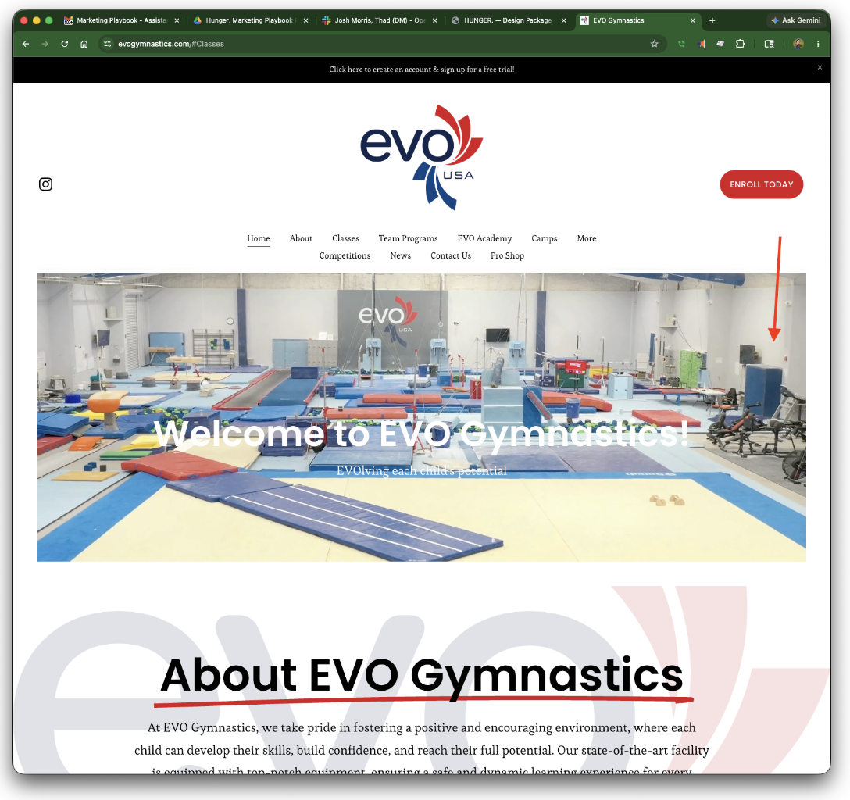
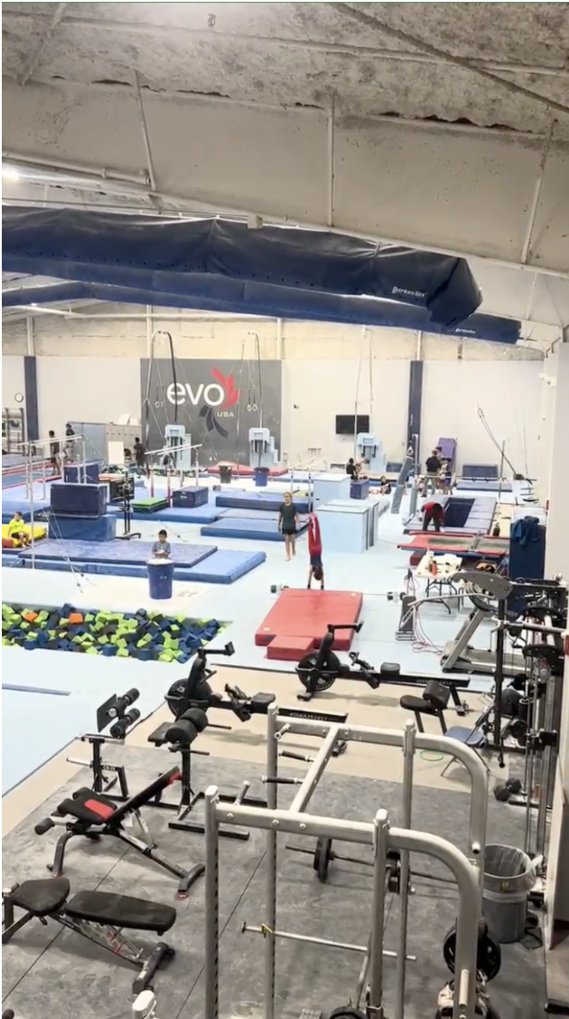
​​
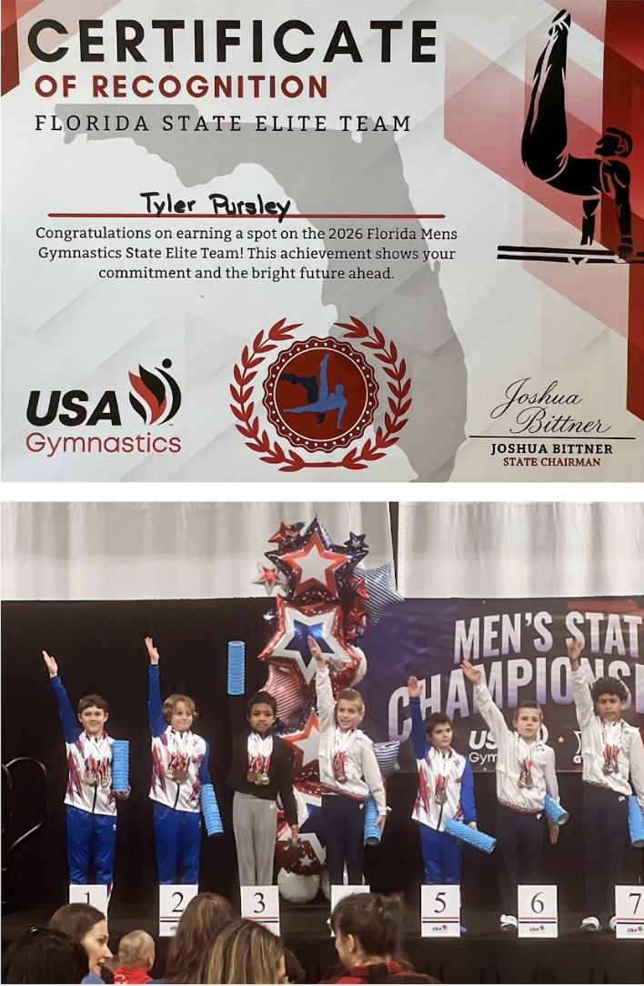
​​


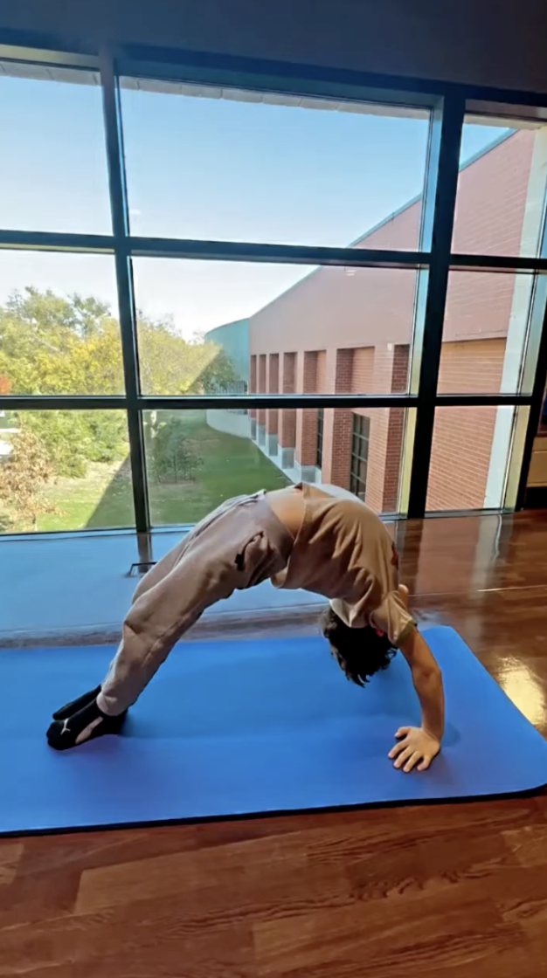

​​

​​
His Mom was on Team Canada training for the Olympics for Giant Slalom. But, got injured and couldn't compete. So, she knows about the grind too...

Personally, I have no idea. I was always just a computer Geek.
I never did “sports ball”. I didn't need to "grind".
I just like engineering computers to do stuff. And, for me, it's easy to do.
Lucky me, I guess. :)

​​
___

___

5) Your diet App Lied to you:

- Might not want to "put down" "diet apps"... seeing that this is also an App?
(too ironic? hypocritical?)
- Unless, the idea is that this App “won’t lie”, like the others do?
- Yes it is built to be in your face, honest but also a directive to changechallenge the status quo of an industry. Just basic motivation isn;t enough. When we launched NoBull 10 years ago it was named that because its true term is No Bullshit. Straight in your face-if you’re an athlete/fitness freak and, want to push the limits of your physical capabilities, we were for you. If not, don’t join us. The value of belonging an dbeing a part of a “tribe” still resonates today and even more so with Gen Z. WE build hunger for that and back it up with science, positivity and being able to be confident in yourself.

Your diet App Lied to you. ->

Your diet is a lie. Be fueled. Get strong. Enjoy.

Stay hungry. Eat enough. Refuse the lie. ->
Stay hungry. Work hard. Refuel.
Stay hungry. Get strong. Eat right.
Stay hungry. Push yourself. Eat what drives you.
Stay hungry. Grind hard. Fuel your body.

Search for joy. Enjoy the search.
Get insights. Take action.
___

___

6) Sleep: Was it the kind that restored you, or just the kind that ended.

Notice: How did you fall asleep? How did you wake?
- The App can record the answers for questions like these and use them for insights and references later?
___

___

7) The App

- The three screens are straight-forward.. e.g.

I got my Gemini agent to whip-up 3 examples based on the screenshots:
They're somewhat "interactive", but not "functional"...
https://hunger-v1-349828425059.us-east1.run.app/
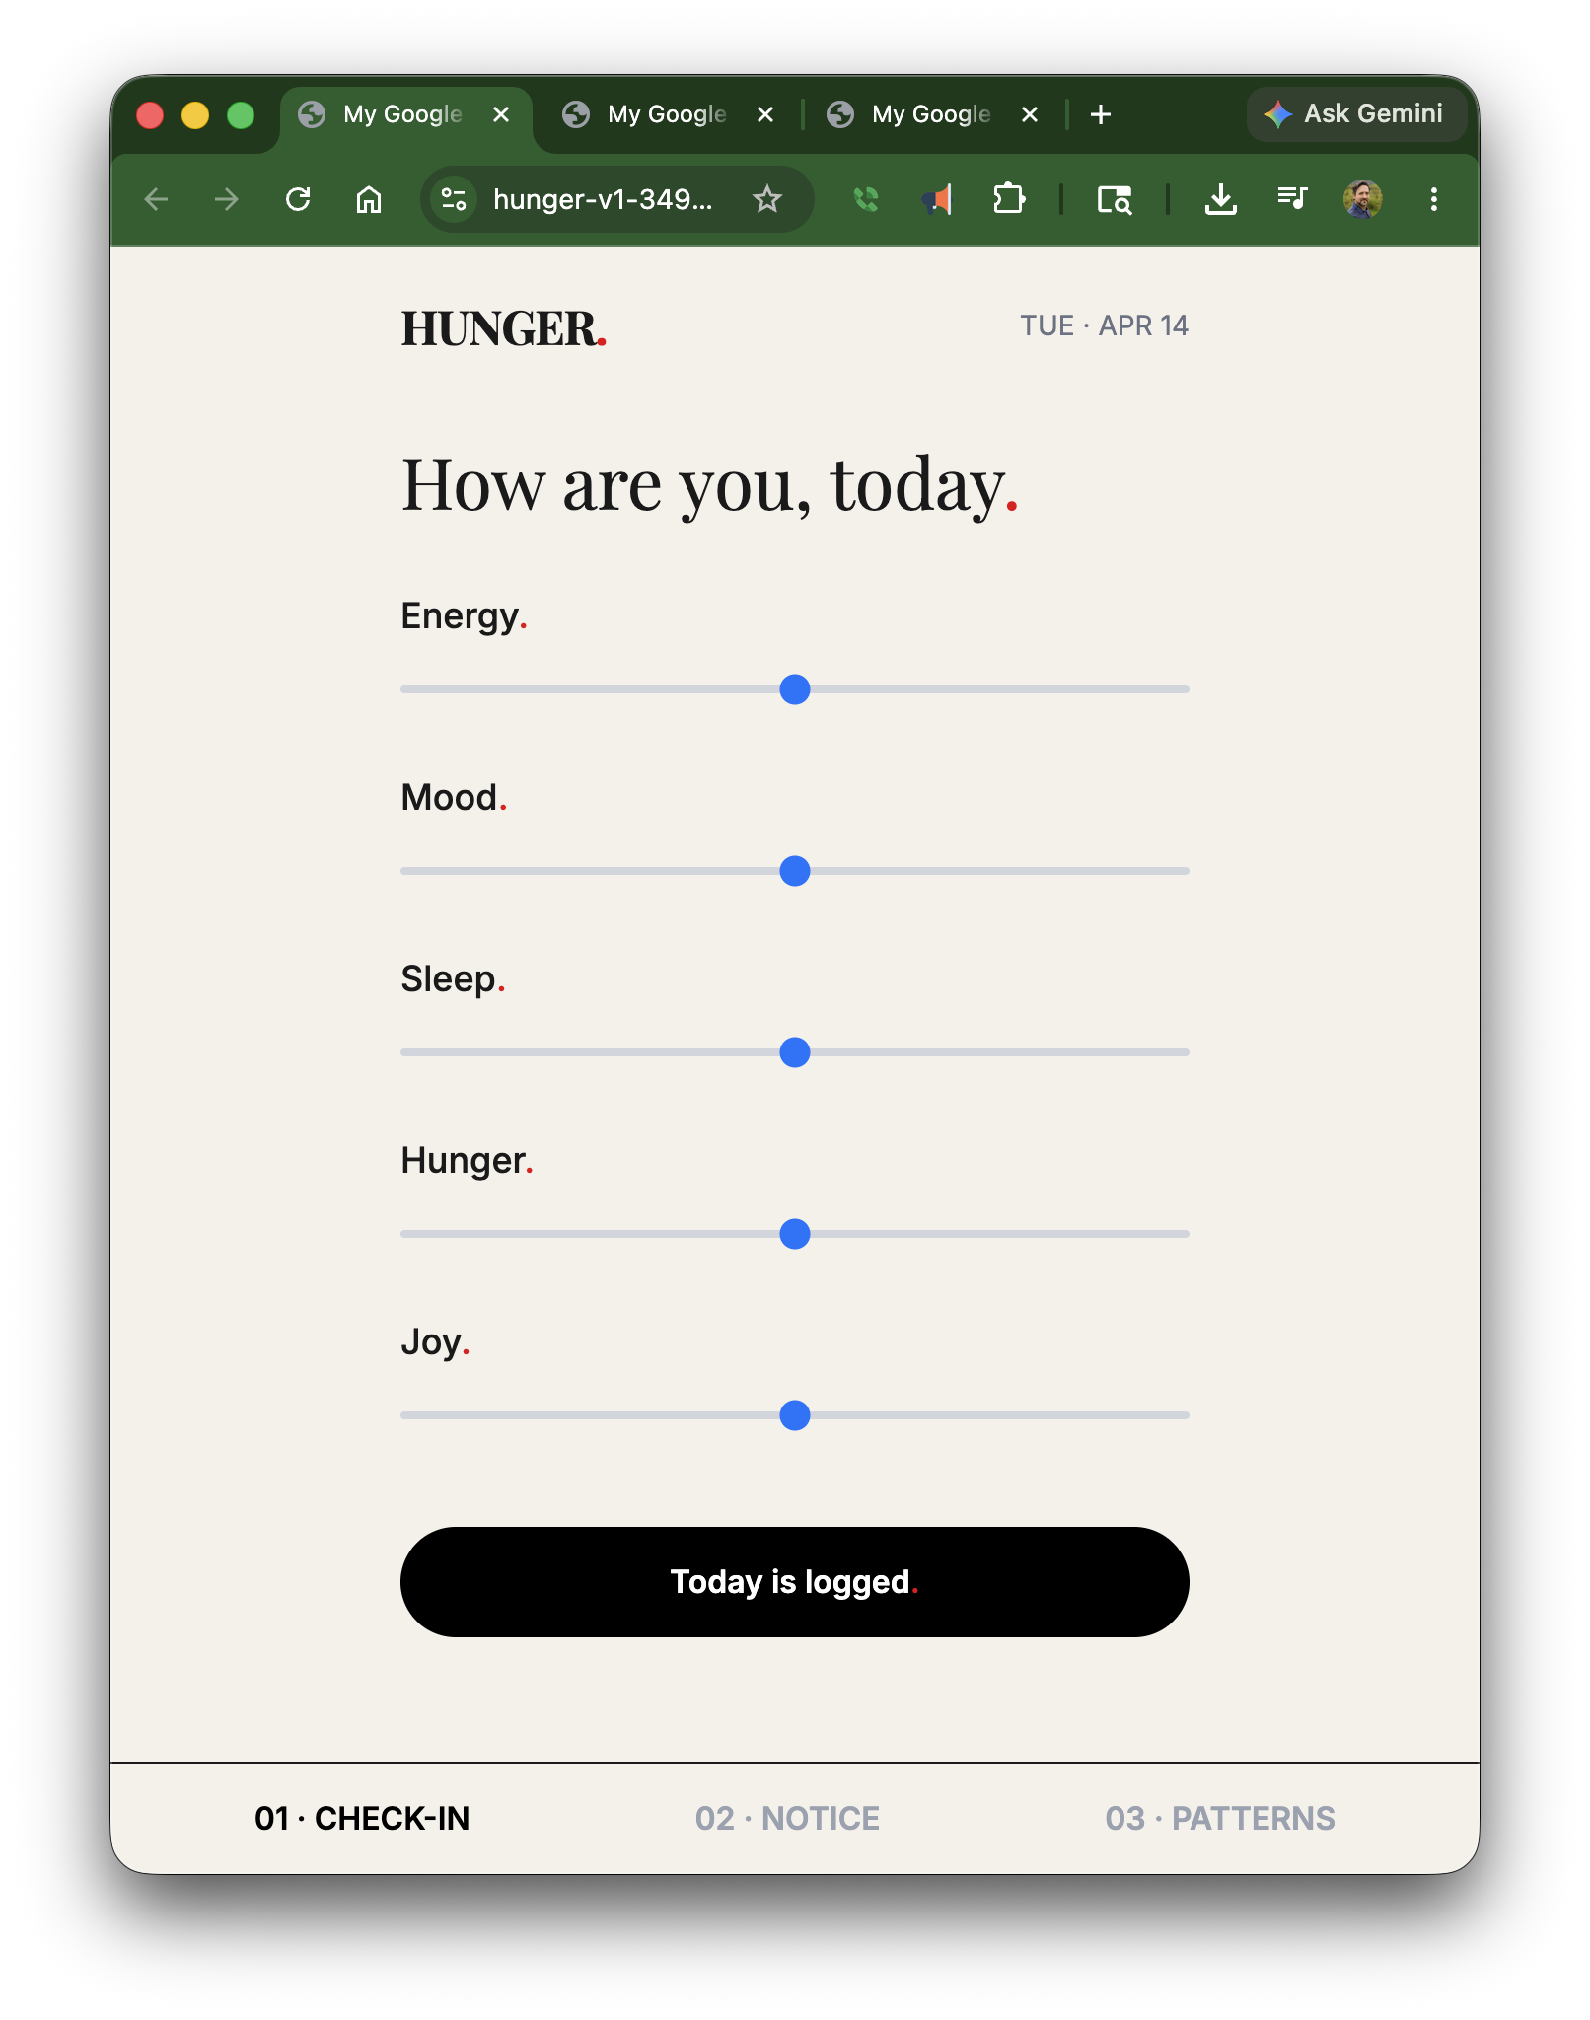
https://hunger-v3-349828425059.us-east1.run.app/
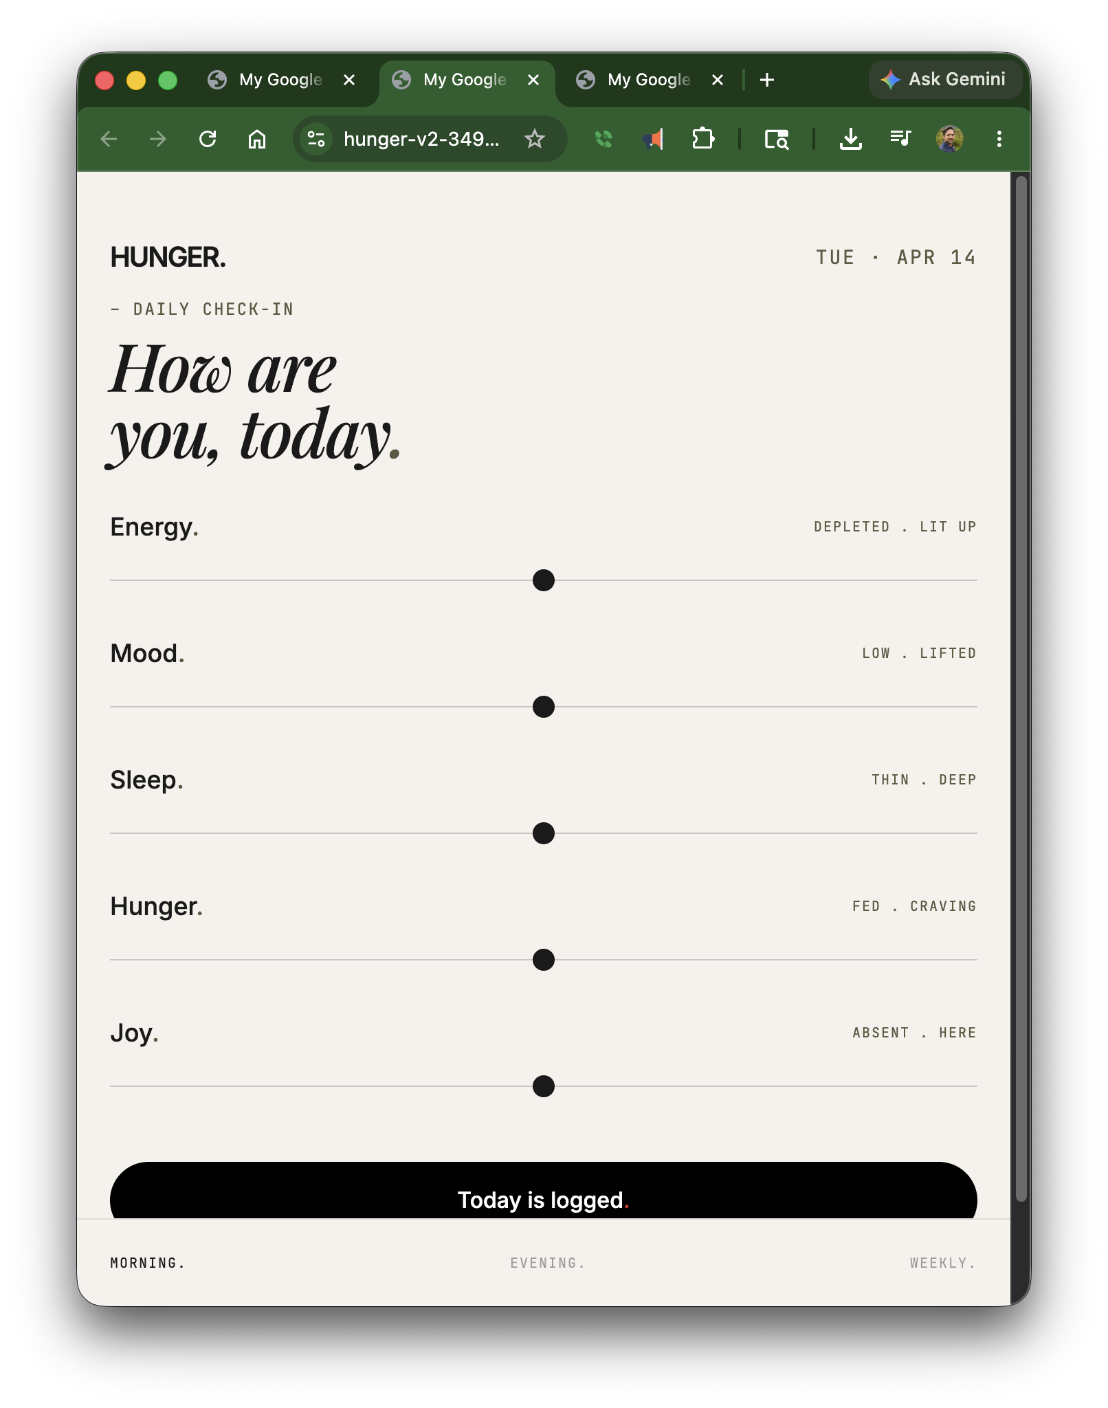
https://hunger-v2-349828425059.us-west1.run.app/
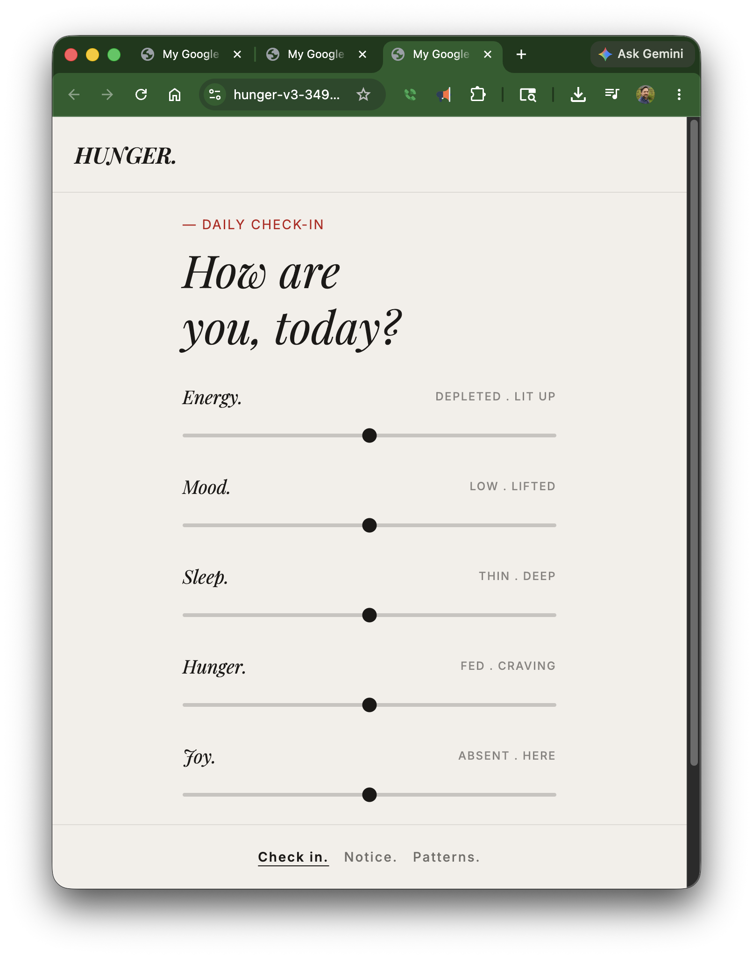

The Web/App MVP would need:
- Authentication: login using Google and Apple accounts (you could use email/password... but storing passwords is riskier)
- Hosting... Google Cloud Run or AWS App Runner
- Database... Google Firebase to load and log the Users data
- App Store Deployment... Apple and Google App stores should have no issue with something simple like this? Though, yes they might reject based on the name alone..

Qs:
- Does the App use Health Connect to also track steps, activity?
- Does the User enter their meal info on the second screen?

Re: A note on “Data”
- Asking for "useful insights" using only "written descriptions" and no data makes you open to more bias in your conclusions/results.
- "Data driven results" are more accurate, actionable and effective.

- Eventually, your phone and AI will be able to notice and log everything you do.. so getting "data driven" results will be easy... but not yet...

Data is good! But, data entry sucks!
- Use conversational voice (or chat) to interview the User to collect their meal data instead?

Here’s some chat/voice scenarios… Are these the kind of thing we’re thinking abouts? Interactions like these? Or something else (if so, give examples)?

Scenario 1:
- Agent: Hey, hows it going?! It looks like you walked for lunch? Good job!

Where did you end up going? Did you meet anyone there? What did you have? Was it good?
- User: Ah yeah, I met up with Alice at that new Greek place. I was good and had chicken on salad. And we shared some humus and tabuli with pita to start. It was actually really good! I'm going back there again!
- Agent: Wow! That sounds awesome! Good proteins, fresh veggies, awesome job! I saw you left home early and didn't have time for your morning jog. Are you gonna try to do that jog when you get home after work?
- User: Yes! I brought my running shorts in the car. I'm gonna stop at the park and run my normal loop before it gets dark. Make sureI leave work before 5:15 or I'll miss it.
- Agent: Ok, I set a timer. Good stuff! You have that 5 mile charity run coming up with Rob in 2 weeks, so try to run at least 3 miles today to keep your distance and endurance up!
- User: Ah yeah good reminder! Ok gotta go, i'll check back when I get home...

Scenario 2:
- Agent: Hey good morning. You're up early today? Before the alarm?
- User: Ah yeah, I did that meditation thing last night and actually went to sleep on time! It worked!
- Agent: How's the energy levels?
- User: Pretty good actually! I'm gonna have some coffee and go for a jog before I eat anything I think...
- Agent: Good call! Better to wait 2 hours after eating before running. Or, do it first! Enjoy the run! Really nice right now. Not too hot yet and no rain to worry about.
- User: Exactly! Ok gotta run. Ping me back after lunch...

Scenario 3:
- Agent: Hey I noticed you logged “Deep Sleep” and “Good Energy”, but “Low Joy” and “Low Mood”. Is everything good?
- User: Yeah, I'm ok. Ryan canceled our plans again last night and we argued about it. I really wanted to go see that band, but I didn't want to go alone. He said he had to work late on some project or something at the office…
- Agent: Ah bummer! Yeah, stuff happens. I just did a search, and I think they're back in town in October. You want a reminder to try again?
- User: Oh really? Yeah, add that to my calendar for two weeks before to see if I'm free... I'm going out for a run.
- Agent: Yeah, sounds good! Keep up with your routine. Ryan's calendar is free for lunch today. Do you want to text and see if he wants to go for sushi?
- User: Ok, yeah thanks. I'll do that when I get back home.. Check in with me later…
___

HUNGER. THE MARKETING PLAYBOOK

___

8) 06. PRE-LAUNCH

Sounds very ambitious... and expensive?
- Nope. Actually pretty easy and very cost effective.

___

9) "Stay hungry." "Eat the sandwich." "Your appetite was the only honest one in the room." ->

Stay hungry. Work hard. Eat the sandwich.
Stay hungry. Grind. Eat the sandwich.

___

10) Pillar 2 — Creator content (25%)

THE REFERRAL THESIS
- What about Influencers and affiliates?
- Affiliates codes give the Affiliates account 25% of the subscription fee? (9 - 30% Apple - 25% = $4/user/month?)

___

11) 22. RISKS

One risk that’s missing in this section. The LLM/AI system… e.g. For these…

- Screenshot 3: The AI coach. A real chat exchange. The coach's voice doing what the brand promises.
- Strict moderation policy: no body-comp talk, no before-and-afters, no "how do I lose 10 pounds" — those questions go to the AI coach in-app, not to the community. The moderation rules are themselves brand voice.
- Within 60 days of launch: does the AI coach generate at least one screenshot per week that someone shares unprompted? If yes, the voice is in the product. If no, the voice is on the website but not in the experience, and we have a much bigger problem than marketing.
- The AI coach saying something a competitor's coach wouldn't say... The product is the character.

This part will be tricky... with current LLM models...

The newest, largest thinking models are super intelligent. They can be witty, and coy and wise and ironic... But, even the newest "live" models are smaller, faster, stupider, no "thinking", limit tool calls, etc... e.g. See “OpenAI CEO Reacts to Viral ChatGPT Video https://www.youtube.com/watch?v=5VRgk7_X7oc”

I'm hacking around that here... ​
​
By getting the live/stupid model to make a tool call to a smarter model to check the database for food, exercise, etc... do the match, etc..
Then return the response from the larger model to the "live" model to send back to the User... But yes, it's tricky... for now...

- The coach's voice doing what the brand promises.
Even with massive (expensive) fine-tuning. Small/fast/non-thinking LLMs are very hard to “control”. They will “make shit up” and they’re too stupid to know it. This is a temporary problem (e.g. SamA said “fixed in one year” above), but it is a risk. If some records your AI Agent doing a thing that’s not “in your script”... or worse.. And that “goes viral”, that could be “Existential”. That’s (likely) a temporary risk… But it’s likelihood is not “Low”

RISK | LIKELIHOOD | SEVERITY | MITIGATION
AI Agent gets recorded/posted telling a User to do something that’s “off brand”, or possibly much worse… | Medium (?) | Existential  (?) | - ??  - Blame the LLM Provider ?  - Limit convos, so they can’t go “off the rails”?  - Fine-tuning and Red Teaming?

If we do some fine-tuning on the LLM ahead of time one some "uncontroversial truisms", and include them in the “System Instruction” that would help… e.g.

___
APPROVED
" Your Diet App Lied To You. Stay Hungry. Stop Apologizing. Built. not shrunk. You Are Not A Number. Eat. Train. Recover. Repeat. The diet industry spent fifty years telling you to ignore your hunger."

NEVER
"Starve to win Empty & strong Hunger pangs = progress Smaller every day Earn it · Cheat day · Burn it off Any reference to weight loss directly Any reference to being smaller Any number on a body. Ever." Like a good Fitness Coach you get excited about my wins!

Health
- Half of everything you eat should be fresh fruits and vegetables.
- Eat when you're hungry. Stop eating before you're full.
- If you're thirsty, you're dehydrated. Keep drinking water throughout the day.
- If you're not sweating, you're not working out.
- Building muscle is hard work. Keeping muscle is harder.
- No pain, No gain. Push through it. Get it done. Enjoy.
- Sleep is the foundation of health. You can't trade it for productivity.
- Your body was made to move. Movement is medicine.
- Take good care of your teeth. They're the only ones you'll get.
- Rest days are when you actually get stronger. Recovery is not optional.
- You can't out-exercise a bad diet. Food is fuel. Choose high-octane.

Grind
- Time is the only resource you can't get back. Spend it wisely.
- You can do anything, but you can't do everything. Pick your priorities.
- Saying "yes" to one thing means saying "no" to another. Protect your bandwidth.
- The best time to start was yesterday. The second best time is today.
- Step up to the plate. Knock it out of the park.
- Hard work is its own reward.
- Don't expect it. Earn it.
- Work hard. Make it happen.
- Show up. Do it right. Get it done.
- Find bad habits. Drop them. Find good habits. Stick to them.

Do it right
- You can't always control the situation, but you can always control your reaction
- Be the change you want to see in the world
- If something's wrong, take responsibility and make it right.
- Search for Joy. Enjoy the search.
- You should help other people. Don't expect anything in return. Giving is the best gift.
- Comparison is the thief of joy. Focus on your own path.
- Failure is just feedback. Learn the lesson. Do it even better next time.
- Discipline keeps you growing. Don't wait to feel like doing it. Start now.
- If you made the mess, you clean it up.
- If you want something you've never had, you have to do something you've never done.

People
- Listen to understand, not just to reply.
- If someone is trying to help, be grateful. If someone is not helping, be honest.
- Don't rely on others to do it for you. This is your life. Make it what you want it to be.
- Actions speak louder than words. Watch the hands, not the mouth.
- Assume positive intent. Give people the benefit of the doubt until proven otherwise.
- You become who you surround yourself with. Choose your circle carefully.
- An apology means nothing without changed behavior.
- Mistakes will happen. Learn from them, don't repeat them.
- Don't be sorry, just don't do it again.
___

Maybe even the “manifesto”? If it’s only 600 words too…

12) THE KILL CRITERIA — AGREED IN ADVANCE

Just a duplicated section here…

____

13) “aestheticized before/afters, weight-loss-first onboarding, comparison feeds”

Ew… those things are gross…

The point of the App is “growth”, its “positive results for the Users”.
The most Users the more “positive results”...

___

14) Apple App Store concerns

Why speculate about if Apple will reject the App name? Just rename an existing Fitness app to “Hunger” and see if it gets rejected… if they approve it without and issue… rename it back. If they reject it, they should also cite the policy it conflicts with?

___

Hunger. Marketing Playbook “Podcast” - Transcript

Hunger. Marketing Playbook Podcast - Transcript

Hunger. An example 600 word manifesto, by Gemini 3.1Pro

We inherited a lie.
We grew up watching our mothers count points and our friends count calories. We were handed a seventy-billion-dollar worldview that sold us a single, quiet directive: shrink. The diet industry spent fifty years telling you to ignore your hunger, building a cage and calling it wellness. They told us that the body is a problem to be managed by restriction, and that the appetite is merely a symptom of failure. They took the very thing that keeps us alive and treated it as the enemy.
They wanted us distracted. They wanted us quiet. They wanted us small.
We refuse the lie.
MyFitnessPal isn't loved, and Noom isn't loved. They are only tolerated, and tolerated is the most beatable position in consumer software. We are the generation that watched the diet industry lie, and we decided to defect. The word "diet" is an embarrassment to us now.
We are done apologizing for having a body. We are done feeling guilty for eating dinner. We are done with streak-shaming, leaderboards, and before-and-after grids. If your fitness app makes you feel guilty for eating dinner, your fitness app is the problem.
Hungry isn't failure. It's information.
It is your body telling you it is awake. It is your engine asking for fuel. When you train hard, you need more. When you sleep poorly, you crave energy. That is not a flaw. That is biology. We take back the words they stole from us. Calorie deficit is real math, while "cheat day" is fake morality. We can hold both.
We are not here to be snatched. We are not here to disappear. We are built, not shrunk.
Forget the scale for a minute. What do you want your body to be capable of? We want to lift heavy, run hard, and take up space. The body is not the trophy. You are not a number. You are a body that knows things. Listen to it.
You trained hard, slept well, and ate light. One of those doesn't fit. Eat the sandwich.
It's 4pm and you've had a coffee. Be serious.
Your protein is at 38g, but you said you wanted to be strong. The math is here when you're ready.
We built an app that treats your appetite as the engine, not the problem. We are not a weight loss app. We are in the fueled performance category. The semantic distinction sounds small, but it is everything.
For fifteen years, the fitness category tried to make people feel watched. The result is the loneliest demographic in modern history using apps that pretend to connect them. Every other app confused connection with comparison. They gave us a scoreboard. We do the opposite. We want a conversation.
Energy. Mood. Sleep. Hunger. Joy.
These are the signals that matter. Plain English. Already in your vocabulary. We don't grade you, and we don't weigh you for feeling them. We do not gamify restrictions. Rest is the feature, not the bug.
Rest is the work. Eat. Train. Recover. Repeat.
We don't do public intake, and we don't pick fights with each other. We picked a fight with the diet industry. We built a tool that listens. A tool that knows the difference between data and surveillance. A tool that stops you when you don't eat enough, because under-fueling is instability.
You are not a project. You are not a transformation.
Stay hungry. Eat enough. Refuse the lie.
____

